|  |  |  |
| --- | --- | --- |
| CSC 111 1.O Programming Assignment | Flight Reservation System | |
| Team El Fuego  Members- H.A.D.G Janith AS2015412  B.G.C.G. Navaratne AS2015482  A.D.N. Rupun AS2015533 | | [Type the document subtitle] |

1. INTRODUCTION
   1. Abstract

Air travel has become less and less cheaper over the years, as a result the no: of passengers has increased considerably. Unlike a train or bus ticket where we have to stand in a queue besides a counter, air tickets are usually booked by computer assisted system. The proposed system is a web portal where the user can book their air travel tickets between two cities online on a particular date. There will be a provision for searching the flights for a travel destination on an input date, the search result will comprise of the full details such as flight no, flight name, cost, arrival and departure time etc. A cancellation option is also given in case user wishes to abandon his travel for various reasons.

* 1. Problem Identification

At present stage all the work is done by manual. So, throughput and response time is too much. Major problem is lack of security check that was must to be applied. Finding out the detail regarding any information was very difficult, because data store in different books and each books at different places. In case of any problem, no one can solve the problem until the master of this field is not present. Airline Reservation System Project in Java is a perfect remedy.

1.3 Working Modules

There are two major modules Admin Module and User Module:

* User Module:

First user will be directed to a booking page where user can type his details such as name, phone, address, nic . User can search seat availability first by giving the departure & destination place and the date of travel in the application. Various flights operating on that day on that route will be displayed. If there is seat available on the flight, user can book a seat or more. For cancellation the user has to type the travel date, user name and the reservation no: for validation.

* Admin Module:

Admin controls and manages the whole portal. Admin adds all basic master entries such as flight details, place details, route details, scheduling etc. Admin can also view user bookings and cancellation of the user.

1.4 Contribution and Team Responsibilities

Our team had divided the work into 3 phrases.

1. B.G.C.G Navaratne

* Add classes
* Add the test classes
* Complete Documentation

1. H.A.D.G. Janith

* Made the GUI forms
* Completing the documentation

1. A.D.N Rupun

* Made the GUI forms
* Add validation methods
* Complete the documents

Screen Shots

(01)

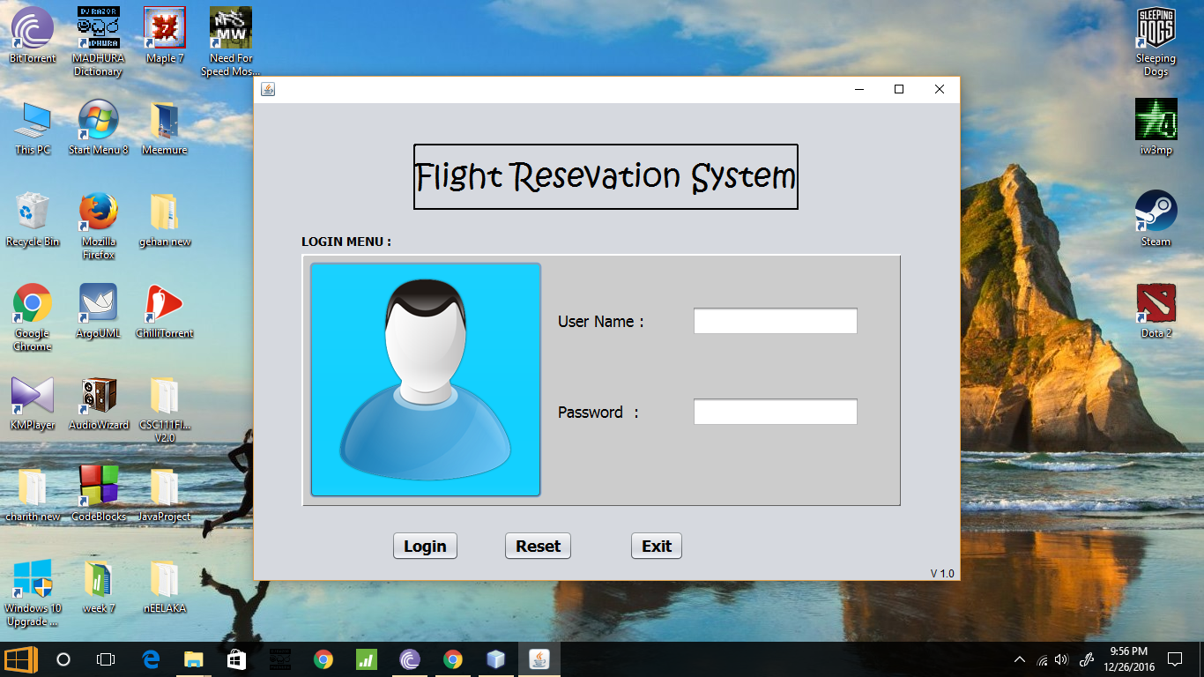

Login Menu of Our Software.

Anyone can logged and reserve. ( User Name :- user / Password :- user )

System Manager ( User Name :- admin / Password :- admin )

If user name or password is wrong. Software give an error massage :

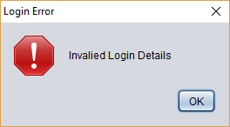

After this massage user should Reset and re-enter his/her user name and password

Unless he/her can Exit.

(02)

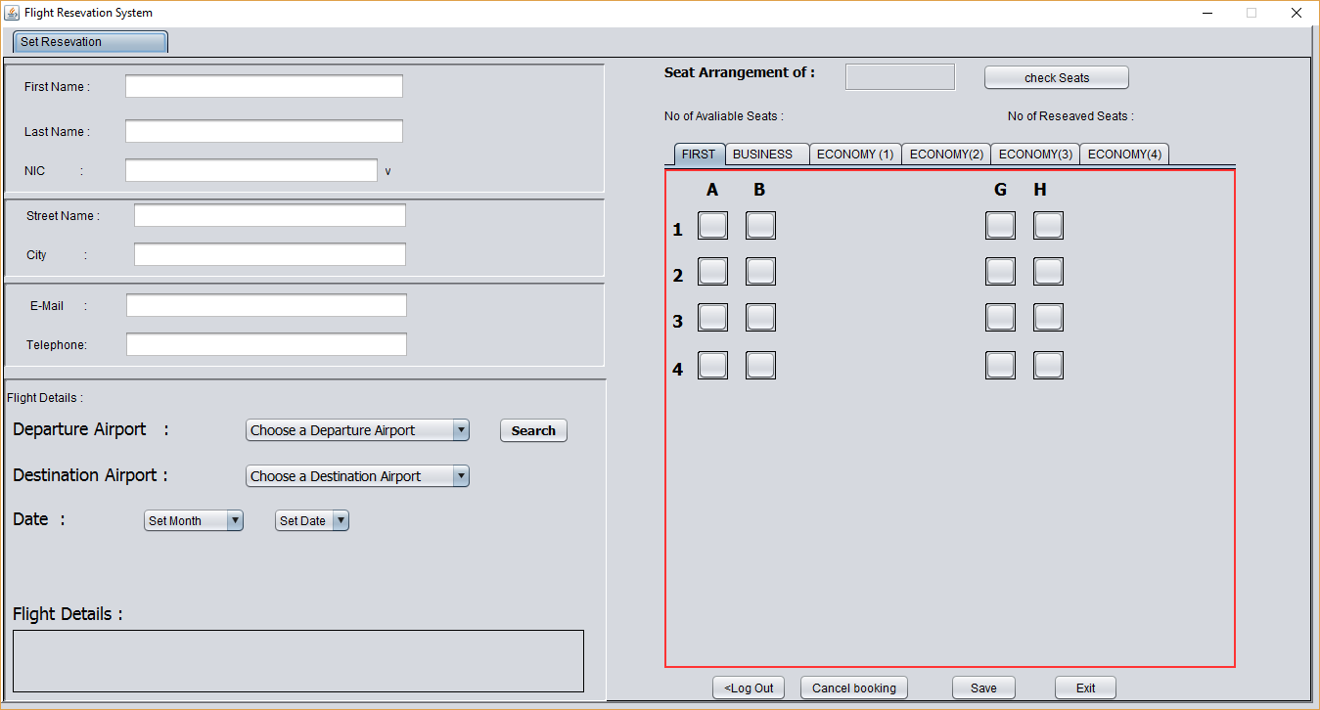

Reservation Form

Passengers can book their flights easily from this.

Cannot save the empty sheet(All should be completed). If anyone save without completing, Software give error massages :

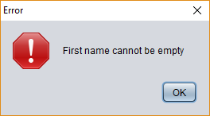

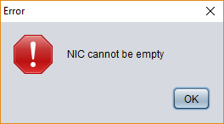

(03)

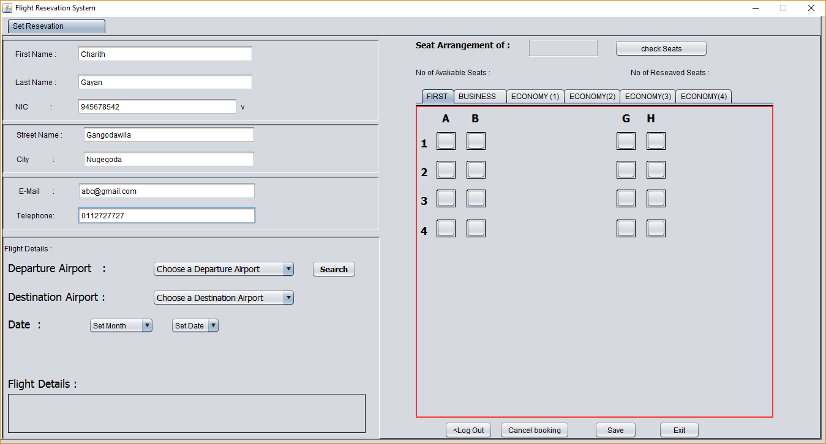

Letters cannot enter in NIC and Telephone cells. If you enter a letter, software gives a BEEP sound.

After completed First name to Telephone cells, Then you can select Departure Airport, Destination Airport and set month and date.

After completing this section Flight Details shown in software if a flight has on that day.

Departure and Destination airports cannot be same. If that is same, In Flight Details is not show anything.

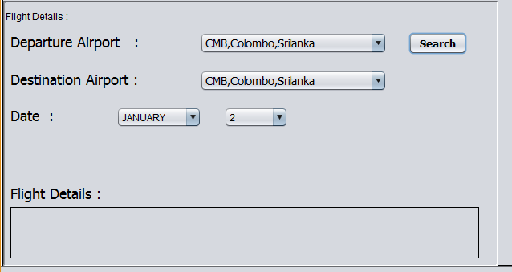

(Departure and Destinations air ports are same)

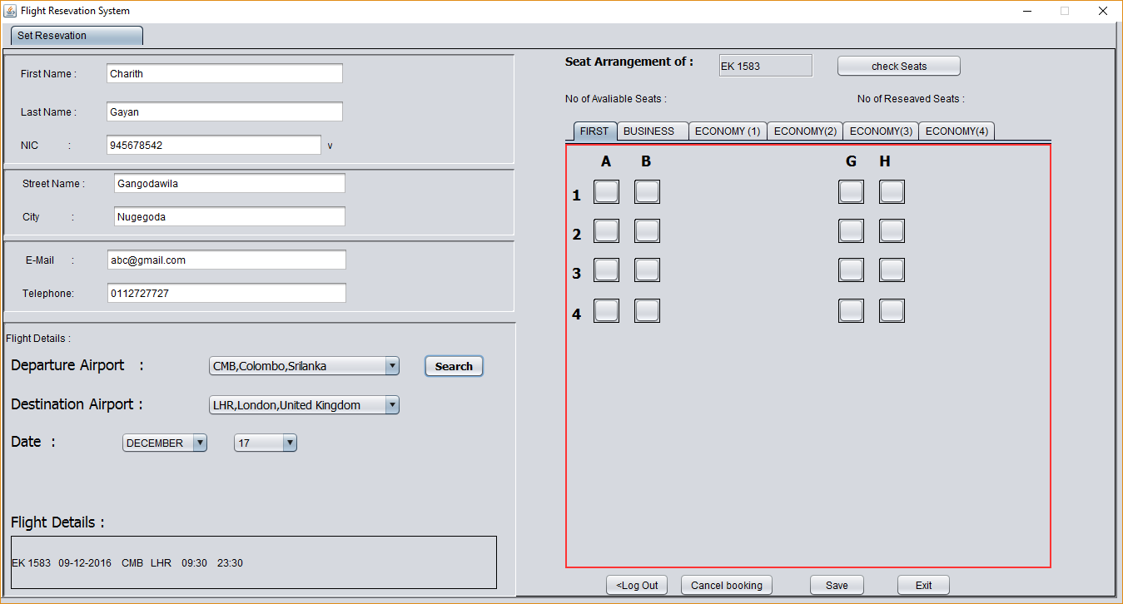

After select rightly, shown flight details and seat arrangement of flight.

There has mainly three flight sections. (First Class, Business Class, Economy Class).

We give seat arrangement, You click on a button and click check seats. (Have 482)

If it booked previously that will show to you.

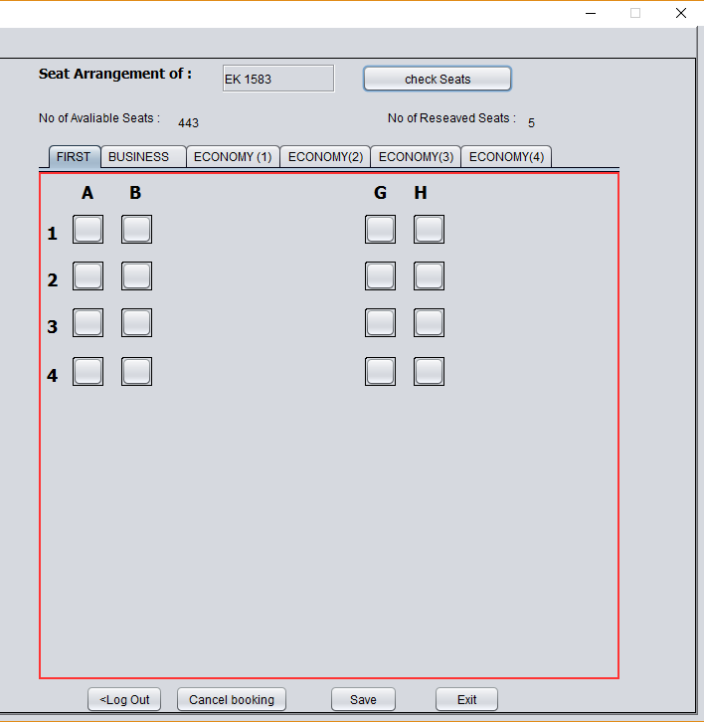

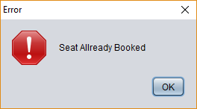

( Error massage of when CLICK ON BOOKED SEAT)

After complete all you can save it.

If you want to cancel your reservation, there is a option that name “cancel booking”

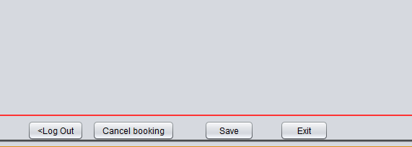

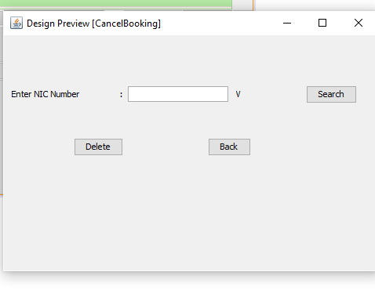

(Cancel Booking Window)

(04)

SYSTEM MANAGER MENU

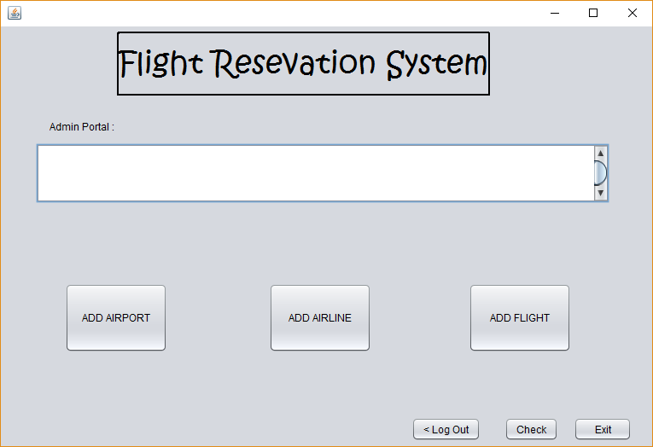

In here, System Manager can check the passengers information from clicking the check button.

Not only that you can Add Airports from clicking the ADD AIRPORT button.

